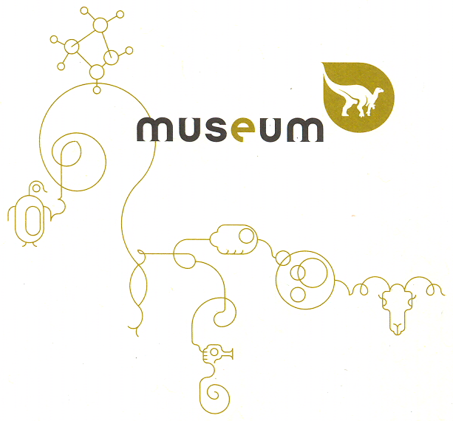

RBINS digitized collection
data user(s) agreement

Digitization of the collection of the Royal Belgian Institute of Natural Sciences (RBINS) is one of the key strategies in managing the collection, preserving it for the future and promoting scientific and popular valorization. The RBINS has its own data repositories to share, distribute and visualize it’s produced digital content. But it also collaborates with other partners like GBIF, VertNet, etc. and has accounts on SketchFab, MorphoSource, … to name a few.
The digital data produced from collection specimens of the RBINS, remains at all times the property of the RBINS. Even when the data is produced by using equipment of which the RBINS is not proprietary, and even when this data is produced within another facility.
In case the digitization is done with your own equipment or in another facility, the data must be shared with RBINS even if the data is not published in order to avoid multiple digitization and guarantee an optimal long term preservation of the data. At your request, the data can remain private for a time period (embargo with a maximum of 24 months) or until it is published, if this period is shorter than the maximum period of embargo.
Upon receiving a loan of specimen(s) of the RBINS collection and the right to scan, image, document the received specimen(s), you hereby agree that any 3D, 2D+ or 2D raw data and original reconstruction(s) produced must be provided to the RBINS 3 months after the digitization and can be used for other academic research following the CC BY (NC) 4.0 after the embargo period.
If you receive 2D, 2D+ or 3D raw data and original reconstruction(s) directly from an RBINS member (Conservator, Scanning Operator), the same restrictions (CC BY (NC) 4.0) regarding the use of the data are present. This means that you can use this data to perform your research and publish your results.
If the digitized material was produced in the framework of an application of Synthesys+ Virtual Access, the data will be available in Open Access after a period of 6 months.
The Virtual loan is granted for a specific purpose. If at any point this data is shared, the RBINS has to be notified. This will be considered as a new virtual loan between the RBINS and the new/other partner.
Reproducing the digital data in a physical way by printing it in 3D, is not allowed without the consent of the RBINS. A new agreement will be made if this was not specified in the present document.
Commercial use of the 3D models or of the 3D printed models is not allowed prior the consent of the RBINS and a the redaction of a specific commercial contract.
Each time the digital data are published, the RBINS and the data provider(s) of the specimen(s) or data have to be acknowledged as follow:
"We thank the [Name of Curator] of the Royal Belgian Institute of Natural Sciences for facilitating access to their imaging facility and digital data and [Name of Operator, (institution if not RBINS)] for operating the scan".
Moreover, a pdf copy of the publication has to be sent to the curator of the physical specimen(s).
It is prohibited to add the raw / original data yourself to data repositories. Before publication, the specimen(s) must be encoded in the DaRWIN database which will create a stable unique identifier. e.g. UUID aa72097c-a3fe-43e0-a651-e2cbbbb76196. This reference allows stable link to the specimen data and metadata and related multimedia material (IIIF image server, Sketchfab, Morphosource, etc). To obtain the unique identifier, please contact the curator in charge of your request.
It is possible to add extra copies of the original data sets on a specific repository if this is required for the scientific publication by the publisher and / or the editor. The link to the original repository and / or stable unique identifier has to be specified.
It is allowed to add modified / altered models on specific repositories. In this case, the link to the original data set has to be specified and the description of the modification(s) has to be provided.
In case you need stable links to your 3D, 2D+, 2D data, notify the RBINS within time and we will add the raw / original data to the RBINS account of the repository(ies), whether it is a RBINS repository or an external one. In this way RBINS can manage their digital collection at any time.
By signing this contract you agree that you are responsible for making sure that this agreement is correctly complied.

Date : 8th June 2021 |  | Date :
Name (RBINS) |  | Name (Third Party)
Patrick Semal  Head of Scientific Service of Heritage |  | Name of Thrid Party
Signature |  | Signature
Contact (email) |  | Contact (email)
patrick.semal@naturalsciences.be

Name and coordinates of the RBINS conservator
xxx
List of the specimens concerned by the present agreement
Specimen no
UUID
Name
Technique
Data Format
Specimens provided by RBINS for digitization by third party: |  |  |  |  |  | YES / NO
Period to provide data: |  |  | 3 months
Period of embargo: |  |  | 24 months
Non commercial use |  | Teaching |  | Exhibition | Publication |  | WEB / SocN
3D model(s) |  | YES / NO |  | YES / NO | YES / NO |  | YES / NO
3D printing |  | YES / NO |  | YES / NO | YES / NO |  | YES / NO

Specimen no
UUID
Name
Technique
Data Format
Specimens provided by RBINS for digitization by third party: |  |  |  |  |  | YES / NO
Period to provide data: |  |  | 3 months
Period of embargo: |  |  | 24 months
Non commercial use |  | Teaching |  | Exhibition | Publication |  | WEB / SocN
3D model(s) |  | YES / NO |  | YES / NO | YES / NO |  | YES / NO
3D printing |  | YES / NO |  | YES / NO | YES / NO |  | YES / NO

Third Party references
Name
Surname
Function
Institution
Laboratory
Address
e-mail

